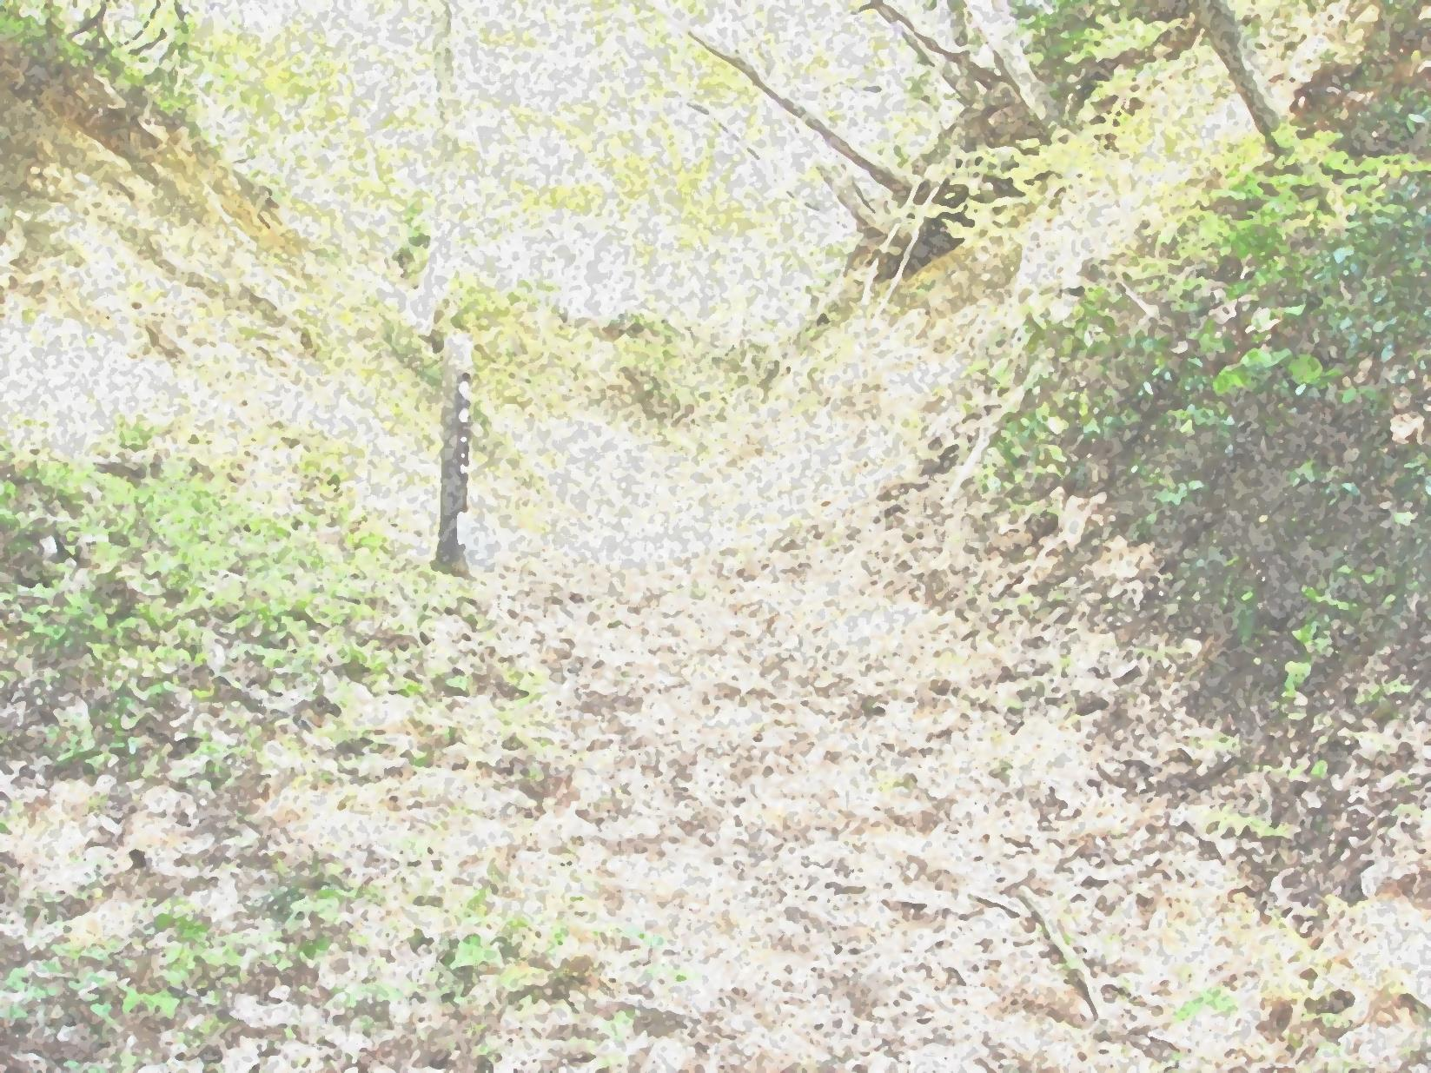
糸魚川世界ジオパーク フォトブック
Geosite
No
６
Itoigawa Global Geopark Photobook
★撮影日時 Time

★撮影場所 Location

★感想・メモ Thoughts

2015（H27）/7 Version 1
ジオまる

糸魚川-静岡構造線・の道（北部）ジオサイト
Itoigawa-Shizuoka Tectonic Line and Salt Trail (North) Geosite
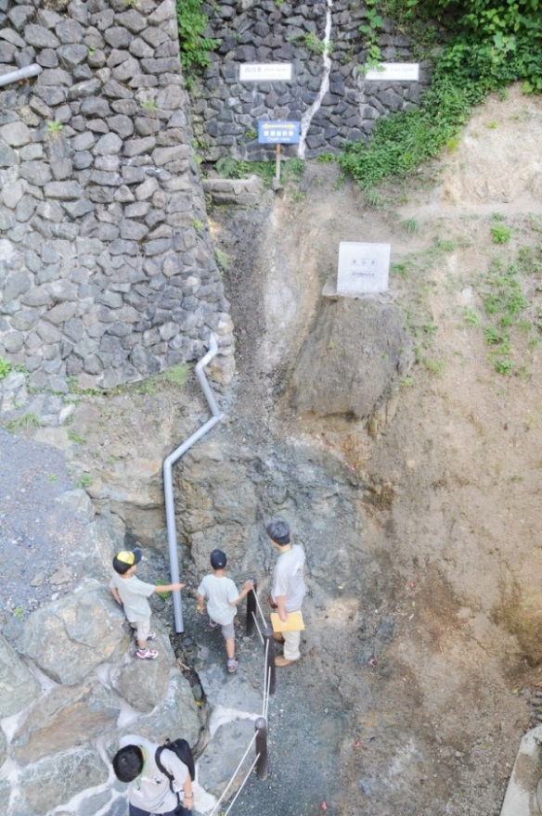
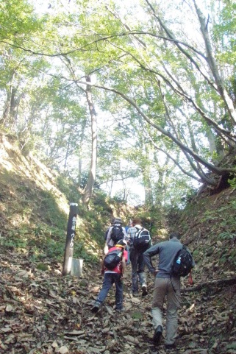
日本列島の東と西の境界をなす糸魚川－静岡構造線（糸静線）を、じかに見学できるジオサイトです。
この大断層に沿うように通る松本街道は日本海と信州を結ぶ生活道路で、「塩の道」と呼ばれました。戦国時代、上杉謙信が武田信玄に塩を送った故事が今に伝わります。

At this geosite, visitors can see the exposed Itoigawa-Shizuoka Tectonic Line, a massive fault splitting the Japanese Islands between east and west.
塩の道 ウトウ
The Salt Trail - Utou
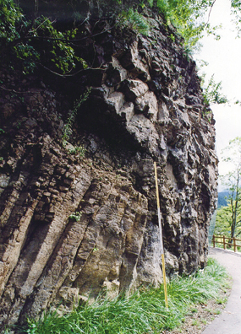
The ancient ‘Matsumoto Highway’ was built along this fault connecting Shinshu Province (Nagano Prefecture) with the Sea of Japan. Also known as the “Salt Trail,” during the Warring States Period, local feudal lord Uesugi Kenshin famously continued salt deliveries along this road to his enemy Takeda Shingen, a story of duty and obligation told to this day.
枕状溶岩
Pillow Lava
ぬーな
フォッサマグナパーク
Fossa Magna Park

