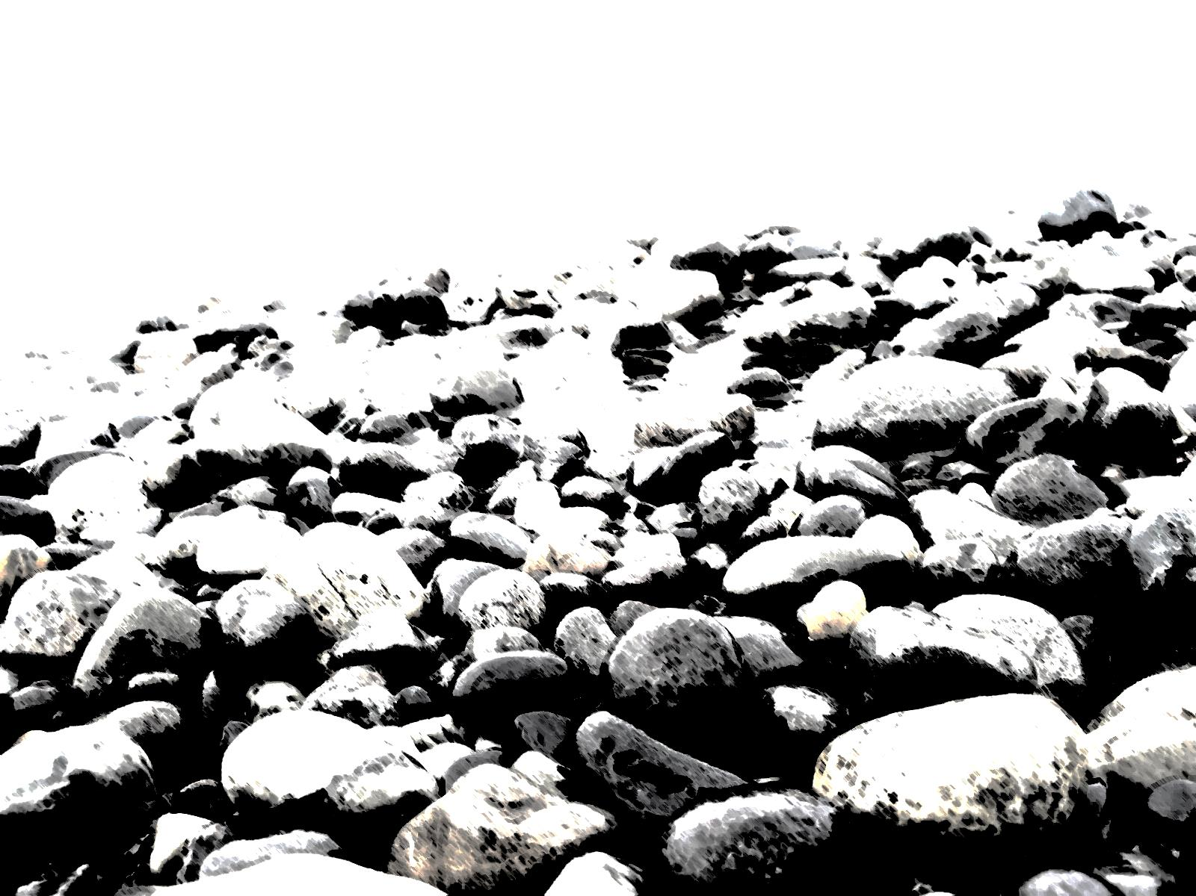
糸魚川世界ジオパーク フォトブック
Geosite
No
３
Itoigawa Global Geopark Photobook
★撮影日時 Time

★撮影場所 Location

★感想・メモ Thoughts

2015（H27）/9 Version 1
ジオまる

青海海岸ジオサイト ～文人のヒスイ海岸
Omi Coast Geosite ～Jomon Culture and Jade
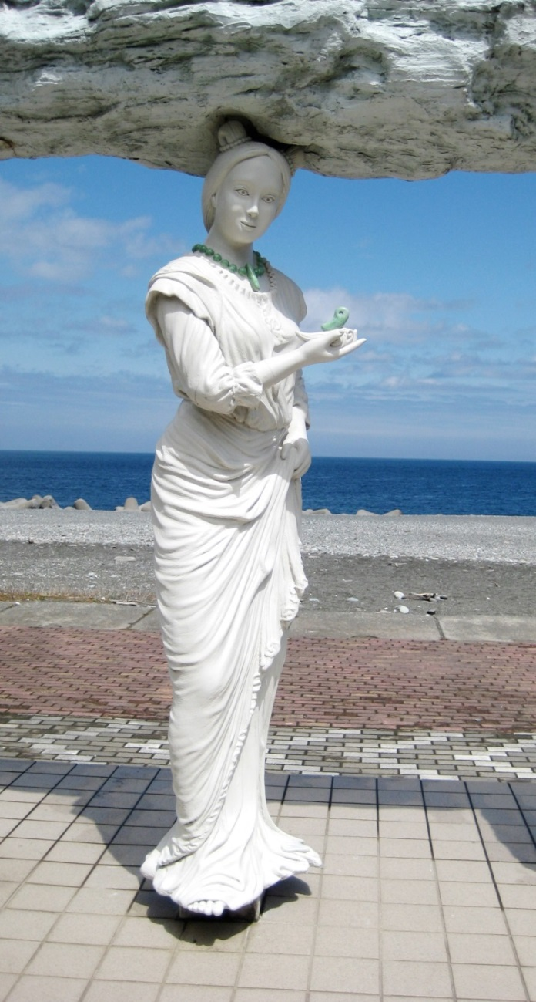
ラベンダービーチ
Lavender Beach
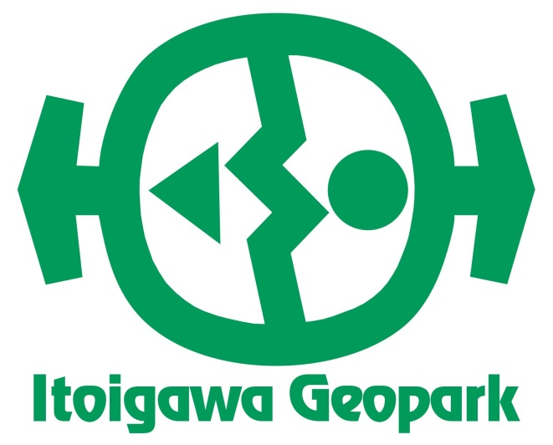
目の前に広がる日本海、ふりかえれば北アルプスの山なみを望む壮大なパノラマが自慢のジオサイト。須沢臨海公園など施設も充実、海岸ではヒスイ探しや石ひろいも楽しめます。
国史跡の遺跡も見どころのひとつ。人とヒスイのかかわりを体感し、縄文文化に思いをはせてみては？
ぬーな

The Sea of Japan spreads across the horizon while the Northern Alps loom behind, creating the panoramic beauty of this Geosite. The site abounds with parks, including the Suzawa and Oumi Seaside Parks, and the coast is excellent for jade hunting.
The Teraji Archaeological Site is a National Historic Landmark where the ancient Jomon people perfected their jadeworking craft. Experience the connection between mankind and jade at this geosite.

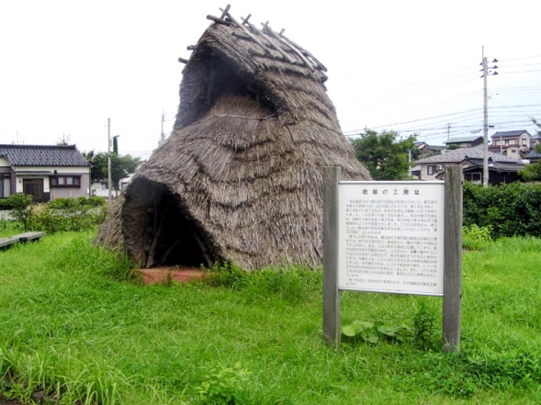
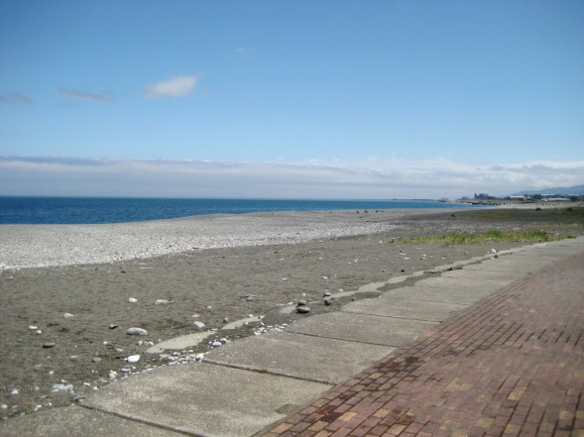

国史跡 寺地遺跡
Teraji Archaeological Site
青海海岸
Omi Coast

